Weekly Class Newsletter

**February 11, 2015**



Hola Padres.

Welcome back! We hope your Winter Break was delightful and restful. Thank you for all the Christmas gifts. They were very thoughtful and much appreciated! I invite all parents to act as aides in the classroom if you have any free time. If this is something that you are interested in doing just call the day before can I can inform you of the activities for that day. Have a great week!

UPCOMING EVENTS:

February 16 – No School (President’s Day)

February 22- No School (Parent-teacher conferences)

ACADEMICS

This week we will be learning about diversity. We will be reading the following books:

* All Kinds of Families by: Mary Ann Hoberman
* It’s a Small World by: Disney
* One Green Apple by: Eve Bunting
* Jack and Jim by: Kitty Crowther

If you could join us Friday during our reading time for diversity day. It will be held close to

the end of the day starting by 1 p.m. the

children will have a show and tell about what they have learned about diversity.

KEEP WORKING ON…..

Math

• Counting to 31

• Counting backwards from 15 or 20

Reading

• Identifies at least 17 letters and their sounds

• Reads at least 13 sight words

Writing

• Forms at least 15 letters correctly.

• Uses beginning and ending sounds of words.

• Uses good spacing between words in a sentence.

**ReCORDATORIOS (REMINDERS)**

We are having parent-teacher conferences this month. They will be held February 22, 2015, between the hours of 8 a.m. and 2 p.m.

OUR THANKS

Community Events

The Orangeburg County Library will be having a Songs, Stories, and Silliness night this Saturday.

You can take your children and participate in songs, rhyme, board tells, and book readings from 3 p.m. to 5 p.m.

There will also be Preschool story time for children ages 3-6. They will be having stories, songs, and finger play. Craft time is also included. This will begin at 10:30 a.m. and end at 11:15 a.m.

If you have any questions or concerns you can contact me by phone at (803) 555-0129, or by email at [Laeshaunb@yahoo.com](mailto:Laeshaunb@yahoo.com). If you cannot make it to the conference day just call and we can set up another time.

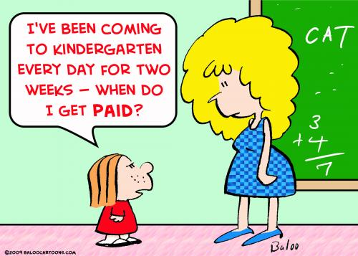

HOMEWORK (TAREA)

Writing Practice

* Writing numbers 0-25 and look for number patterns. Practice making lowercase Magic C letters: a, c, g, o, d, q, e and s. Also practice Diver Letters: r, m, n, h, p, and b. (See back for writing paper.)

Reading Practice

* Memorizing new sight words. Reread a favorite story and place the events in order.

Math

* Along with the New Year we started a new math program for our shapes unit. This curriculum includes homework. Please complete the worksheets at home and keep them there so you may continue to practice the concepts throughout each week. The homework for this week focuses on naming and describing shapes. Have fun!